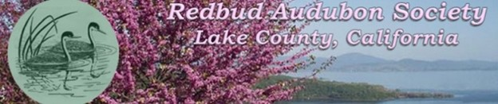
Dear Redbud Audubon supporter,
The Redbud Audubon Society is now over 50 years old. We were founded by a group of caring citizens in 1974 and since that time our mission has been to raise public awareness and appreciation of bird life and the natural environment of our beautiful Clear Lake and Lake County.
We provide nature education to adults and children and strive to create a social atmosphere that encourages individuals from diverse backgrounds to participate in our events. We collaborate with farmers, developers, businesspeople, tribal partners, and resort owners to expand their knowledge of the importance of birds, both for our individual well-being and for the economic well-being of our area.
We have experienced many challenges, and we are now faced with the challenge of raising enough funds to pay for our continued operation which includes insurance, our social and print media costs, and renumeration for our presenters and speakers.
We receive a small annual contribution from National Audubon for members signing up for the first year, but it is to you -- our local supporters -- that we look to for help right now.
In this end of year giving time, please consider giving to the Redbud Audubon Society.
There are many ways you can accomplish this. You can send a check in the enclosed envelope; donate online through our website or talk to your financial advisor about making a Qualified Charitable Donation through your Required Minimum Distribution of your IRA. This is a painless way to contribute and helps you to avoid taxes on the amount that you donate to a non-profit like the Redbud Audubon Society.
Sincerely,
Redbud Audubon Society Board of Directors
PO Box 5780, Clearlake, CA 95422
Phone 707/805-9410
Email: redbud.audubon@gmail.com

